**Assignment 8:**

1. **Write a program to draw the following pattern**

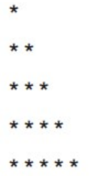

#include<stdio.h>

int main()

{

int i,j;

for(i=1;i<=5;i++)

{

for(j=1;j<=5;j++)

{

if(j<=i)

{

printf("*");

}

else

{

printf(" ");

}

}

printf("\n");

}

return 0;

}

1. 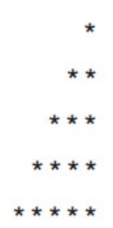**Write a program to draw the following pattern**

#include<stdio.h>

int main()

{

int i,j;

for(i=1;i<=5;i++)

{

for(j=1;j<=5;j++)

{

if(j>=(6-i))

{

printf("*");

}

else

{

printf(" ");

}

}

printf("\n");

}

return 0;

}

1. 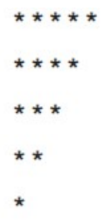**Write a program to draw the following pattern**

#include<stdio.h>

int main()

{

int i,j;

for(i=1;i<=5;i++)

{

for(j=1;j<=5;j++)

{

if(j<=(6-i))

{

printf("*");

}

else

{

printf(" ");

}

}

printf("\n");

}

return 0;

}

1. **Write a program to draw the following pattern**

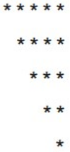

#include<stdio.h>

int main()

{

int i,j;

for(i=1;i<=5;i++)

{

for(j=1;j<=5;j++)

{

if(j>=i)

{

printf("*");

}

else

{

printf(" ");

}

}

printf("\n");

}

return 0;

}

1. **Write a program to draw the following pattern**

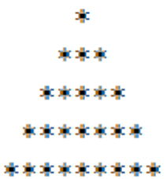

#include<stdio.h>

int main()

{

int i,j;

for(i=1;i<=5;i++)

{

for(j=1;j<=9;j++)

{

if(j>5-i&&j<5+i)

{

printf("*");

}

else

{

printf(" ");

}

}

printf("\n");

}

return 0;

}

1. **Write a program to draw the following pattern**

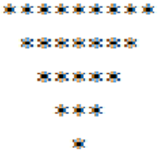

#include<stdio.h>

int main()

{

int i,j;

for(i=1;i<=5;i++)

{

for(j=1;j<=9;j++)

{

if(j>=i&&j<=10-i)

{

printf("*");

}

else

{

printf(" ");

}

}

printf("\n");

}

return 0;

}

1. **Write a program to draw the following pattern**

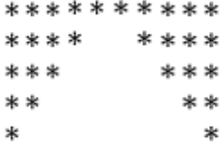

#include<stdio.h>

int main()

{

int i,j;

for(i=1;i<=5;i++)

{

for(j=1;j<=10;j++)

{

if(j<=6-i||j>=5+i)

{

printf("*");

}

else

{

printf(" ");

}

}

printf("\n");

}

return 0;

}

1. **Write a program to draw the following pattern**

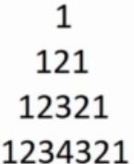

#include<stdio.h>

int main()

{

int i,j,k;

for(i=1;i<=4;i++)

{

k=1;

for(j=1;j<=7;j++)

{

if(j>=5-i&&j<=3+i)

{

printf("%d",k);

if(j<4)

k++;

else

k--;

}

else

{

printf(" ");

}

}

printf("\n");

}

return 0;

}

1. **Write a program to draw the following pattern**

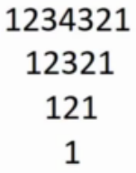

#include<stdio.h>

int main()

{

int i,j,k;

for(i=1;i<=4;i++)

{

k=1;

for(j=1;j<=7;j++)

{

if(j>=i&&j<=8-i)

{

printf("%d",k);

if(j<4)

k++;

else

k--;

}

else

{

printf(" ");

}

}

printf("\n");

}

return 0;

}

1. **Write a program to draw the following pattern**

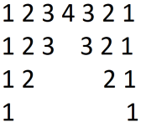

#include<stdio.h>

int main()

{

int i,j,k,flag=0;

for(i=1;i<=4;i++)

{

k=1;

for(j=1;j<=7;j++)

{

if(j<=5-i||j>=3+i)

{

if(flag==1)

{

k--;

flag=0;

}

printf("%d",k);

if(j<4)

k++;

else

k--;

}

else

{

flag=1;

printf(" ");

}

}

printf("\n");

}

return 0;

}

1. **Write a program to draw the following pattern**

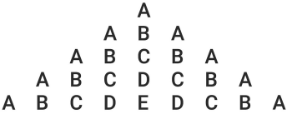

#include<stdio.h>

int main()

{

int i,j,k;

for(i=1;i<=5;i++)

{

k=65;

for(j=1;j<=9;j++)

{

if(j>=6-i&&j<=4+i)

{

printf("%c",k);

if(j<5)

k++;

else

k--;

}

else

{

printf(" ");

}

}

printf("\n");

}

return 0;

}

1. **Write a program to draw the following pattern**

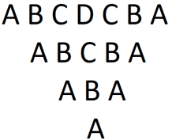

#include<stdio.h>

int main()

{

int i,j,k;

for(i=1;i<=4;i++)

{

k=65;

for(j=1;j<=7;j++)

{

if(j>=i&&j<=8-i)

{

printf("%c",k);

if(j<4)

k++;

else

k--;

}

else

{

printf(" ");

}

}

printf("\n");

}

return 0;

}

1. **Write a program to draw the following pattern**

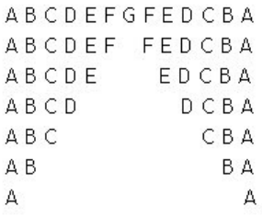

#include<stdio.h>

int main()

{

int i,j,k,flag=0;

for(i=1;i<=7;i++)

{

k=65;

for(j=1;j<=13;j++)

{

if(j<=8-i||j>=6+i)

{

if(flag==1)

{

k--;

flag=0;

}

printf("%c",k);

if(j<7)

k++;

else

k--;

}

else

{

flag=1;

printf(" ");

}

}

printf("\n");

}

return 0;

}

1. **Write a program to draw the following pattern**

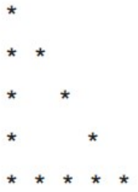

#include<stdio.h>

int main()

{

int i,j;

for(i=1;i<=5;i++)

{

for(j=1;j<=5;j++)

{

if(i==5||j==1||i==j)

{

printf("*");

}

else

{

printf(" ");

}

}

printf("\n");

}

return 0;

}

1. **Write a program to draw the following pattern**

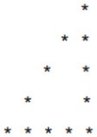

#include<stdio.h>

int main()

{

int i,j;

for(i=1;i<=5;i++)

{

for(j=1;j<=5;j++)

{

if(i==5||j==5||j==6-i)

{

printf("*");

}

else

{

printf(" ");

}

}

printf("\n");

}

return 0;

}

1. **Write a program to draw the following pattern**

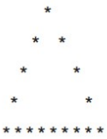

#include<stdio.h>

int main()

{

int i,j;

for(i=1;i<=5;i++)

{

for(j=1;j<=9;j++)

{

if(i==5||j==6-i||j==4+i)

{

printf("*");

}

else

{

printf(" ");

}

}

printf("\n");

}

return 0;

}

1. **Write a program to draw the following pattern**

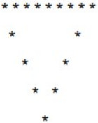

#include<stdio.h>

int main()

{

int i,j;

for(i=1;i<=5;i++)

{

for(j=1;j<=9;j++)

{

if(i==1||j==10-i||j==i)

{

printf("*");

}

else

{

printf(" ");

}

}

printf("\n");

}

return 0;

}

1. **Write a program to draw the following pattern**

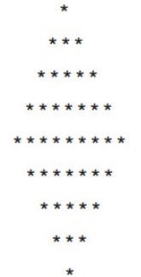

#include<stdio.h>

int main()

{

int i,j;

for(i=1;i<=5;i++)

{

for(j=1;j<=9;j++)

{

if(j>=6-i&&j<=4+i)

{

printf("*");

}

else

{

printf(" ");

}

}

printf("\n");

}

for(i=2;i<=5;i++)

{

for(j=1;j<=9;j++)

{

if(j>=i&&j<=10-i)

{

printf("*");

}

else

{

printf(" ");

}

}

printf("\n");

}

return 0;

}

1. **Write a program to draw the following pattern**

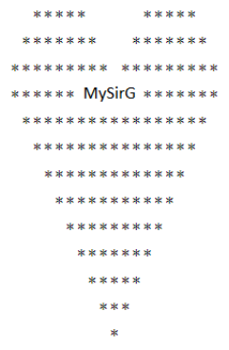

#include<stdio.h>

int main()

{

int i,j;

for(i=1;i<=3;i++)

{

for(j=1;j<=19;j++)

{

if((j>=4-i&&j<=6+i)||(j>=14-i&&j<=16+i))

{

printf("*");

}

else

{

printf(" ");

}

}

printf("\n");

}

for(i=1;i<=10;i++)

{

for(j=1;j<=19;j++)

{

if(i==1&&j==8)

printf("MySirG");

if(i==1&&j>=8&&j<=13)

continue;

if(j>=i&&j<=20-i)

{

printf("*");

}

else

{

printf(" ");

}

}

printf("\n");

}

return 0;

}